CPE301 – SPRING 2019

Design Assignment 1

Steven Lee

5003887117

Lees106@Unlv.nevada.edu

Primary Github address: <https://github.com/lees106>

Directory: /submission_da

1. **COMPONENTS LIST AND CONNECTION BLOCK DIAGRAM w/ PINS**

Atmel Studio 7

1. **DEVELOPED CODE OF TASK 1/A**

/*

* Steven Lee, 5003887117, Created 2/16/2019

* CPE 301 Design Assignment 1

* Multiplication with 16-bit multiplicand and 8-bit multiplier

* Result limits: 24-bits

*/

.include<m328pdef.inc>

.org 0x00

ldi r25,0xFF ; Load R25 = 0xFF (High byte Multiplicand)

ldi r24,0xFF ; Load R24 = 0xFF (Low byte Multiplicand)

ldi r22,0xFF ; Load R22 = 0xFF (Multiplier)

ldi r17,0x00 ; Load R17 = 0x00 (Zero constant)

L1: add r18,r24 ; Add R18 = R18 + R24

adc r19,r25 ; Add R19 = R19 + R25 + Carry

adc r20,r17 ; Add R20 = R20 + R17 + Carry

DEC r22 ; Decrement R22 (Multiplier)

BRNE L1 ; R22 != 0 ? Loop again L1 : Exit

end: rjmp end

1. **DEVELOPED HIGH LEVEL CODE OF TASK 3/A from TASK 1/A**

/*

* Steven Lee, 5003887117, Created 2/16/2019

* CPE 301 Design Assignment 1

* Multiplication with 16-bit multiplicand and 8-bit multiplier

* Result limits: 24-bits

*/

#include<iostream>

#include<cmath>

using namespace std;

int main() {

unsigned int multiplicand;

unsigned int multiplier;

unsigned int result;

cout << "Enter multiplicand: 0x";

cin >> hex >> multiplicand;

cout << "Enter multiplier: 0x";

cin >> hex >> multiplier;

result = multiplicand * multiplier;

cout << "Result: 0x" << hex << result << endl;

return 0;

}

1. **SCREENSHOTS OF EACH TASK OUTPUT (ATMEL STUDIO OUTPUT)**

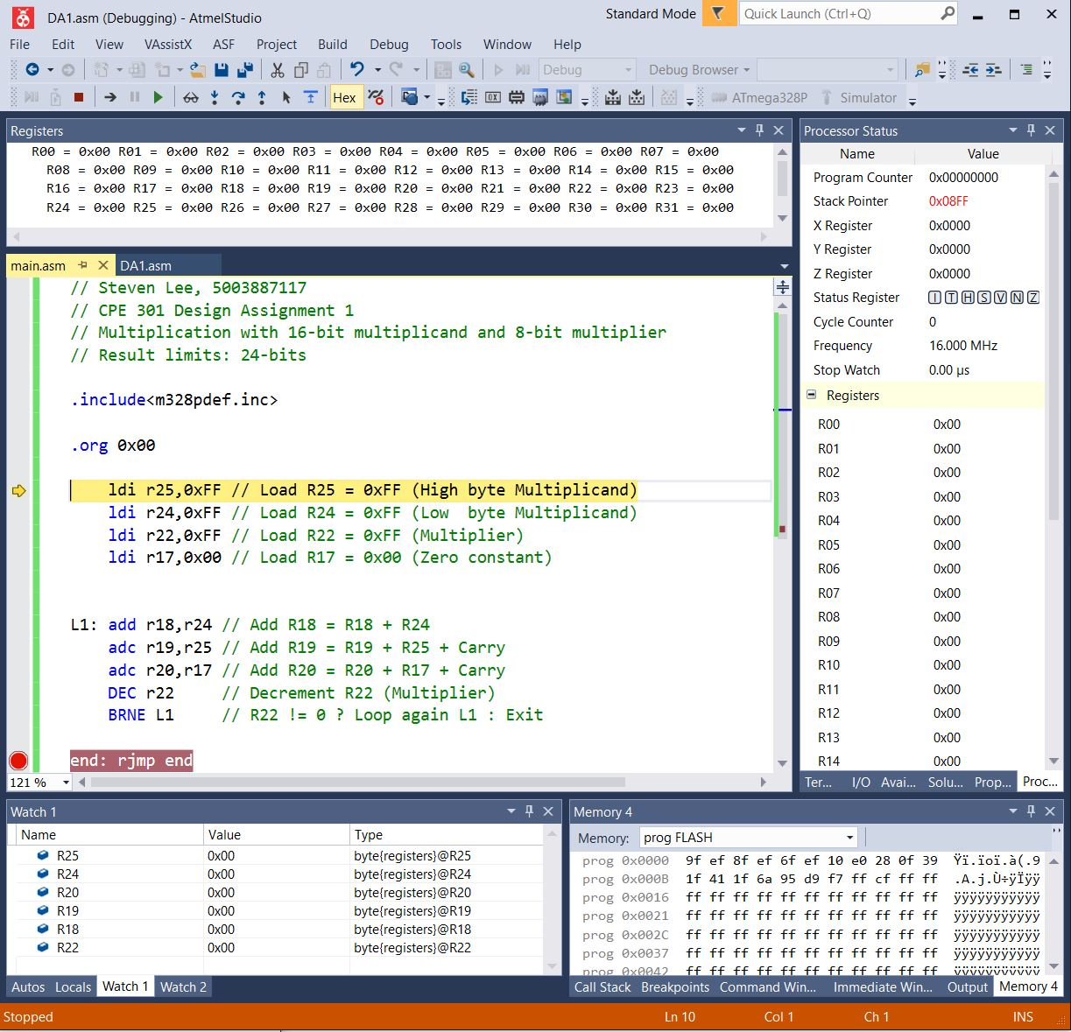Before debugging:

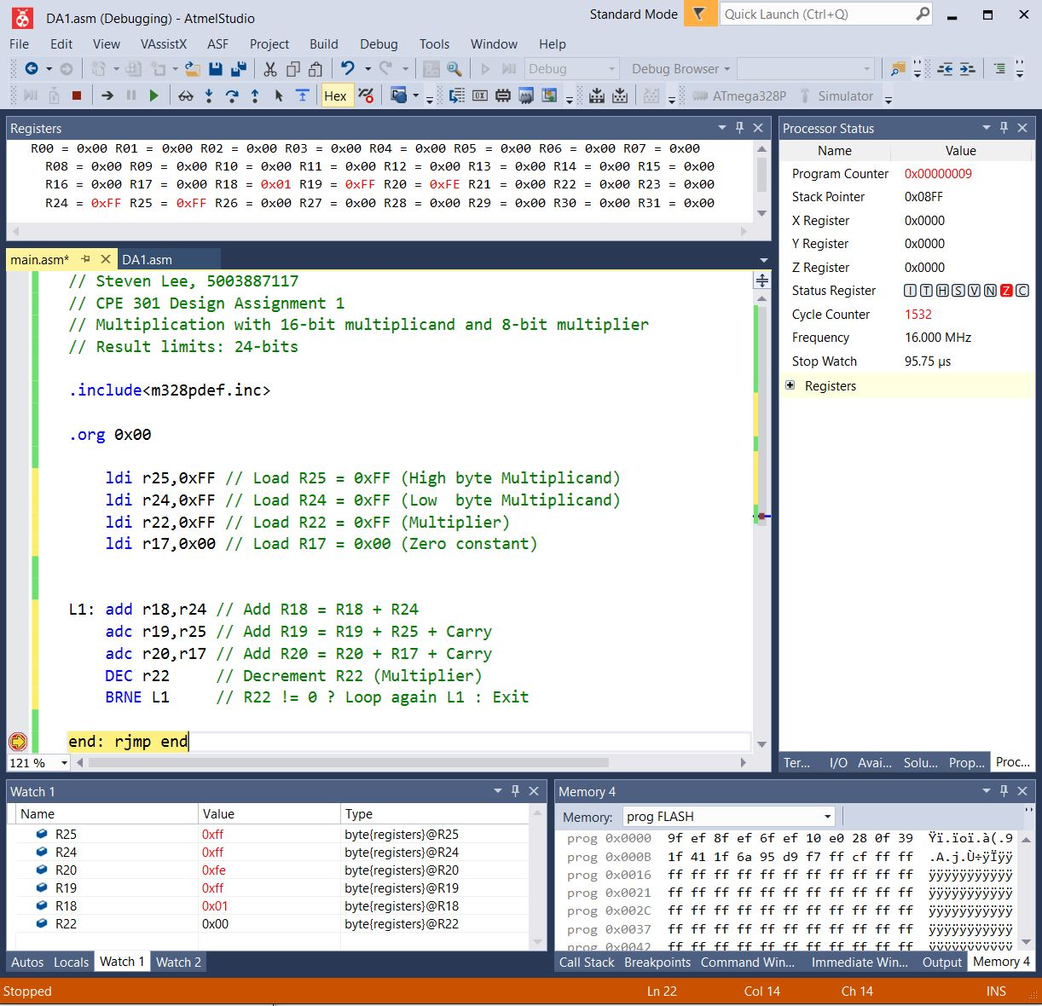Post Debugging:

1. **SCREENSHOT OF EXECUTION TIME @ 16MHz /#CYCLES**

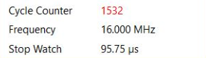

1. **SCREENSHOT OF HIGH-LEVEL PROGRAM**

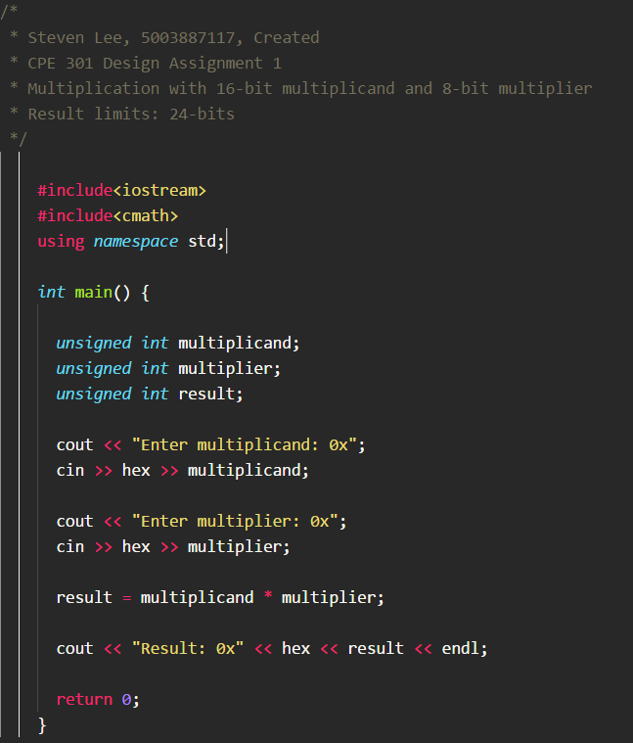

1. **SCREENSHOT OF HIGH-LEVEL PROGRAM EXECUTION**

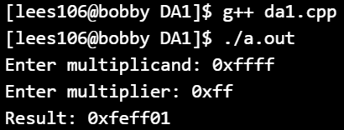

1. **GITHUB LINK OF THIS DA**

<https://github.com/lees106/submission_da/tree/master/DesignAssignments/DA1A>

**Student Academic Misconduct Policy**

<http://studentconduct.unlv.edu/misconduct/policy.html>

“This assignment submission is my own, original work”.

STEVEN LEE